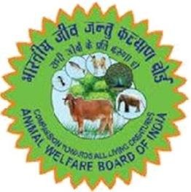ANIMAL WELFARE BOARD OF INDIA

Ministry of Fisheries, Animal Husbandry and Dairying, Govt. of India (Department of Animal Husbandry and Dairying)

NIAW Campus, 42 KM Mile Stone, Delhi-Agra Highway NH-2, Ballabhgarh, Haryana-121004

Email: [support-awbi@gov.in](mailto:support-awbi@gov.in) : Website: [www.awbi.gov.in](http://www.awbi.gov.in)

# Grievance Complaint Registration Form

|  |  |  |
| --- | --- | --- |
| 1 | **Type of Grievance** |  |
| 2 | **Grievance Details** |  |
|  | Complaint Text |  |
|  | Supporting document/image/video, if any |  |
| 3 | **Details of old Grievance, if any** |  |